**Sprint 2 Plan**

*Okinawa Memory Initiative*

*The Okinawaners*

**Sprint Completion Date**: 11/4/18

**Revision:** 1.1

**Revision Date:** 11/4/18

**Goal:**

We want to start having a connected backend and be able to create as means of viewing the home page, events, donate page, and documents page. We also want an about page to see whos apart of the project, a document page to see the historical archive of Okinawa, and an article page so that I can read what OMI posted.

**User Story 1:**

As a User, I want to be able to view the Vault Tab, so that I may see content, to be able to post my stories to be part of the community, to be able to see the gallery, videos, and articles of a selected category to have a full view of all content within that category.

Task 1.1: Create the jumbotron (1 hour)

Task 1.2: Create the Videos, Article, and Gallery subsections (1 hour)

Task 1.3: Create the hover-on article effect using Grid/box layout (1 hour)

Task 1.4: Create featured article section with accompanying Subscribe section (1 hour)

Task 1.5: Create View More feature (1 hour)

**User Story 2:**

As a user, I want to be able to access the Article page within the Vault page, so that I can view documents related to Okinawa.

Task 2.1: Create parsing feature that would allocate the right image with its respective description. (2 hours)

Task 2.2: Create layout where multiple article posts can be displayed on one screen. (1 hour)

Task 2.3: Make the page dynamic according to the backend, which sorts the information to the assigned layout. (2 hours)

**User Story 3:**

As a user, I want to be able to access the Videos within the Vault page, so that I may view any media pertaining to Okinawa.

Task 3.1: Create separate Video page that would display Youtube videos regarding appropriate content regarding The Battle of Okinawa, Okinawa as a U.S. Base, and its consequences. (2 hours)

Task 3.2: Have the Youtube videos dynamic and have the appropriate ones show up (3 hour)

**User Story 4:**

As a user, I want to be able to access the Home, so that I can get a description of the website and know who is part of the University undergraduate research group.

Task 4.1: Create Home Page (1 hour)

Task 4.2: Create map feature that would display interactive Map of Okinawa (3 hours)

Task 4.3: Write Description and Introduction for the website (<1 hour)

**User Story 5:** As a user, I want to view the Documents pages, so that I would be able to see the historical archive of Okinawa.

Task 5.1: Create jumbotron (1 hour)

Task 5.2: Create general layout for both the filter column and the individual squares for each documents (2 hours)

Task 5.3: Create separate filter section to the left of the page (1 hour)

Task 5.4: Create separate section where each document will dynamically show up (1 hour)

Task 5.5: Make the Documents page work dynamically where the documents are sorted from the database and displayed on the user interface (2 hours)

Task 5.6: Make filter feature work appropriately (1 hour)

**User Story 6:**

As a user, I want to be able to login to the website, so that I can share document with the community.

Task 6.1: Set up Django (1 hour)

Task 6.2: Connect with Firebase for login (2 hours)

Task 6.3: Create/ Login service on django (2 hours)

Task 6.4: Create Login/ Signup pages on React (2 hours)

Task 6.5: Integrate (3 hours)

**Team Roles:**

Kevin Tran: Project Owner, {UI design, Frontend}

Jeff Liao: Backend, {Frontend}

Tina Peng: Frontend {UI design, Backend}

Wellford Chan: Front End { Back End Integration }

Ankita Upadhyay: Backend {Frontend}

Alfred George Francisco Milan III: Frontend {Full Stack, Backend}

**Task Assignments:**

Kevin Tran: (User Story 2: Task 4)

Jeff Liao: (User Story 2: Task 1, Task 2)

Tina Peng: (User Story 1: Task 2, Task 10)

Wellford Chan: (User Story 1: Task 4, Task 9)

Ankita Upadhyay: (User Story 1: Task 3, Task 7)

Alfred George Francisco Milan III: (User Story 1: Task 1, Task 7, Task 10)

**Initial Scrum Board:**

|  |  |  |  |
| --- | --- | --- | --- |
| Stories | ToDo | In Progress | Done |
| As a user, I want to be able to use the website and to be able to see the following pages: Home, About, Vault, Documents, Events, Donate, Gail Project, Login. | **Task 1.3:** Create the hover-on article effect using Grid/box layout (1 hour)  **Task 1.5:** Create View More feature (1 hour)  **Task 2.1:** Create parsing feature that would allocate the right image with its respective description. (2 hours)  **Task 2.3:** Make the page dynamic according to the backend, which sorts the information to the assigned layout. (2 hours)  **Task 3.2:** Have the Youtube videos dynamic and have the appropriate ones show up (3 hour)  **Task 5.6:** Make filter feature work appropriately (1 hour)  **Task 5.5:** Make the Documents page work dynamically where the documents are sorted from the database and displayed on the user interface (2 hours) | **Task 1.2:** Create the Videos, Article, and Gallery subsections (1 hour)  **Task 1.4:** Create featured article section with accompanying Subscribe section (1 hour)  **Task 2.2:** Create layout where multiple article posts can be displayed on one screen. (1 hour)  **Task 3.1:** Create separate Video page that would display Youtube videos regarding appropriate content regarding The Battle of Okinawa, Okinawa as a U.S. Base, and its consequences. (2 hours)  **Task 4.2:** Create map feature that would display interactive Map of Okinawa (3 hours)  **Task 5.3:** Create separate filter section to the left of the page (1 hour)  **Task 5.4:** Create separate section where each document will dynamically show up (1 hour) | **Task 1.1:** Create the jumbotron (1 hour)  **Task 4.1:** Create Home Page (1 hour)  **Task 4.3:** Write Description and Introduction for the website (<1 hour)  **Task 5.1:** Create jumbotron (1 hour)  **Task 5.2:** Create general layout for both the filter column and the individual squares for each documents (2 hours)  **Task 5.3:** Create separate filter section to the left of the page (1 hour)  **Task 5.4:** Create separate section where each document will dynamically show up (1 hour) |
| As a user, I want to be able to see the documents from the database | **Task 6.2:** Connect with Firebase for login (2 hours)  **Task 6.5:** Integrate (3 hours) | **Task 6.1:** Set up Django (1 hour)  **Task 6.3:** Create/ Login service on django (2 hours) | **Task 6.4:** Create Login/ Signup pages on React (2 hours) |

**Initial Burn Up Chart:**

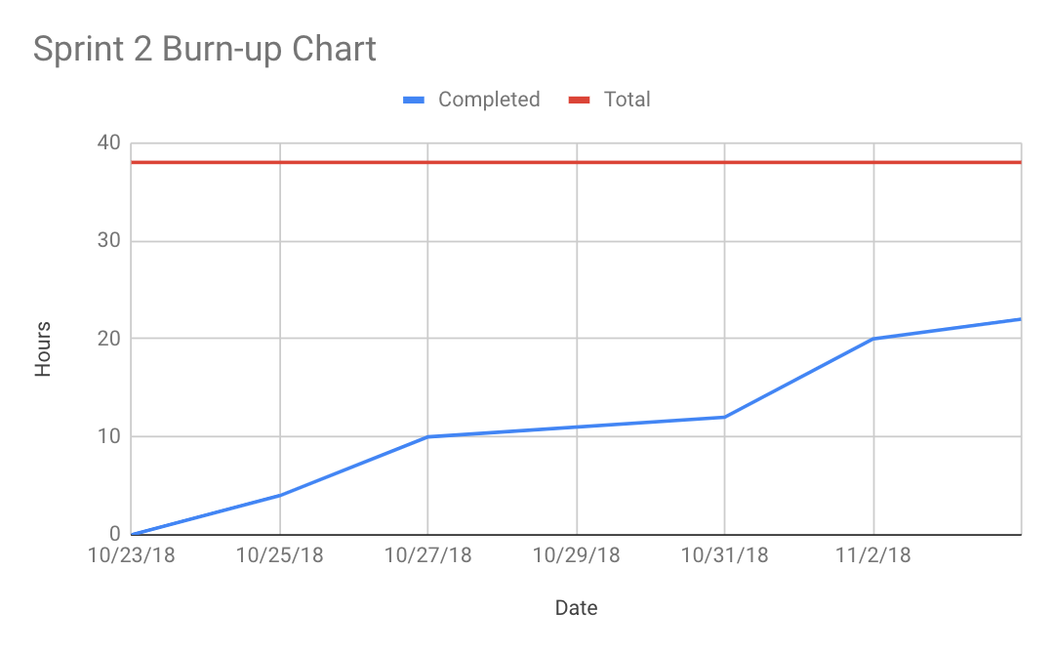

**Scrum Times:**

Tuesday 3:30pm

Thursday 2:00pm

Sunday 7:00pm